Topic Analysis of UN Member Foreign Policy Goals

Since the fall of the Soviet Union in 1991, the United States has been widely considered the most influential country in the world. Its widespread reach should be easily seen in how its foreign policy affects other countries in the world. A great way to illustrate this effect is to analyze speeches from the annual UN General Debate. Every September at the UN General Assembly, every member state addresses all other members via speech regarding their perspective on current world events and priorities. In order to see how influential US foreign policy is in this circle, we will be conducting a LDA topic analysis on these speeches post-1991. This will give us a list of topics from each country’s speeches that we can compare with the US to assess how similar they are.

We will start by identifying some countries we can use as roughly representative of the broader world view. I decided on Mexico, China, and Great Britain, all for different reasons. Great Britain is one of the United States’ closest allies, and thus should mirror their foreign policy goals. China, on the other hand, has emerged as the United States’ biggest rival on the international stage. Their perspectives on the world are bound to be at odds in some fashion. Mexico is an ally of the US, but isn’t in the same influential or wealthy position. Its concerns may be different as a result.

Analyzing the United States speeches provides unsurprising results. The predominant foreign policy objective in recent decades has been the war on terror. This is illustrated in each topics’ likely terms containing many references to terrorism and national security. The remainder of the topics seem to revolve around a sense of globalism and unity. In the powerful position of the US, it makes sense that its best interest would be for other countries to unite behind its philosophy and influence.

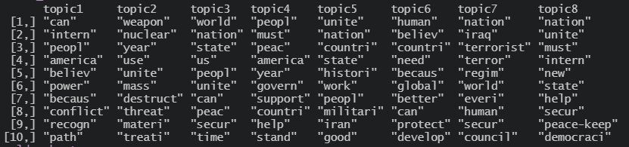

Great Britain shares many foreign policy objectives as the US, but focuses less on the war on terror. There is a wider spread of international conflicts that appear in these topics, including leaving the European Union and the Syrian and Bosnian conflicts. There is also mention of climate change, which was absent for in the United States’ likely terms. As a representation of its priorities, it is clear that Great Britain’s speeches have leaned more towards concrete issues rather than a simplistic call for unity.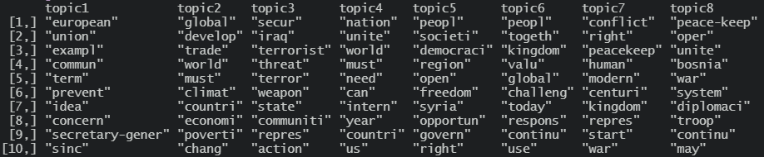

As a country with less international influence, Mexico’s interests seem more internal than the more developed and wealthy nations of Great Britain and the United States. This is demonstrated with the mentions of the drug cartels, and trafficking. There is also a higher frequency of climate change discussion. Unfortunately, climate change is an issue where many wealthier contribute disproportionately to the problem while the ramifications disproportionately affect poorer nations in a negative manner. It is understandable why a country like Mexico would see this as a more pressing issue. In stark contrast to the United States’ unifying tone, Mexico is asking for support and solidarity. As the US calls for countries to join them and unite under their agenda, the less fortunate ones must simply point out alternative concerns. Although the difference on paper is minor, the tone shift is representative of the different mentalities of the wealthy and less wealthy nations.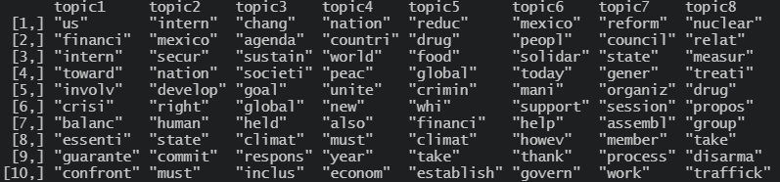

China’s priorities are completely different than the United States’, as shown by their emphasis on economy and culture. Even their foreign policy goals are different. For China, its main interests are not in suppressing terrorism and increasing world security. Instead, they would like to expand their economy sphere of influence and keep its occupied territory culturally homogenous. This is why there are mentions of their economic projects in Africa and their continued “situation” with Taiwan. However, there are still some similarities with the US. Most prominently, they both share an emphasis on globalism and unity as the two most powerful nations in the world. This, despite their foreign policy differences, is what aligns them more in comparison to Great Britain and Mexico.

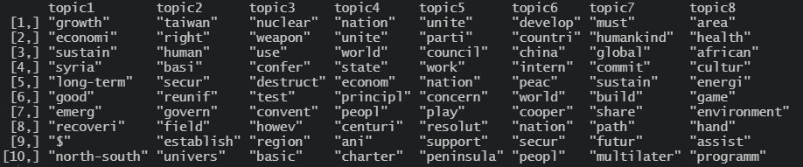

There are some limitations with the method that I have chosen for this analysis. The most obvious concern is the overall validity of the countries that I used. I tried to pick countries that were representative of the world at-large. This meant choosing a close US ally, a less close ally with less wealth, and a powerful adversary. This may not paint a super complete picture. Another limitation is the specific method of text analysis. Using LDA gives us high frequency terms, but it is entirely possible that significant issues with a short lifespan did not end up appearing on the final list of topics. The overall analysis is ultimately beholden to the words given by the analysis, so if there is any flaw in the accuracy of the algorithm, the interpretation would be based off of incomplete representation of the data.

The topic model analysis shows that the United States does have a substantial influence in foreign policy among its allies. The War on Terror, specifically, was an issue that most directly impacted the US, and was picked up as a talking point by its allies in a big way. In contrast, China’s main domestically stemming foreign policy concern, Taiwan, did not see much discussion from the other countries analyzed. However, based on this analysis, that the rest of the world is ahead on the issue of discussing climate change internationally. Despite its overwhelming influence, the US is not always first to the table with every issue, but its concerns do tend to become the concerns of the rest of the world.